# **Front-End Technologies Basics – Exam Preparation I**

This document defines the exam preparation assignments for the   
**"QA Front-End Automation" Course @ SoftUni**

## DOM Manipulation

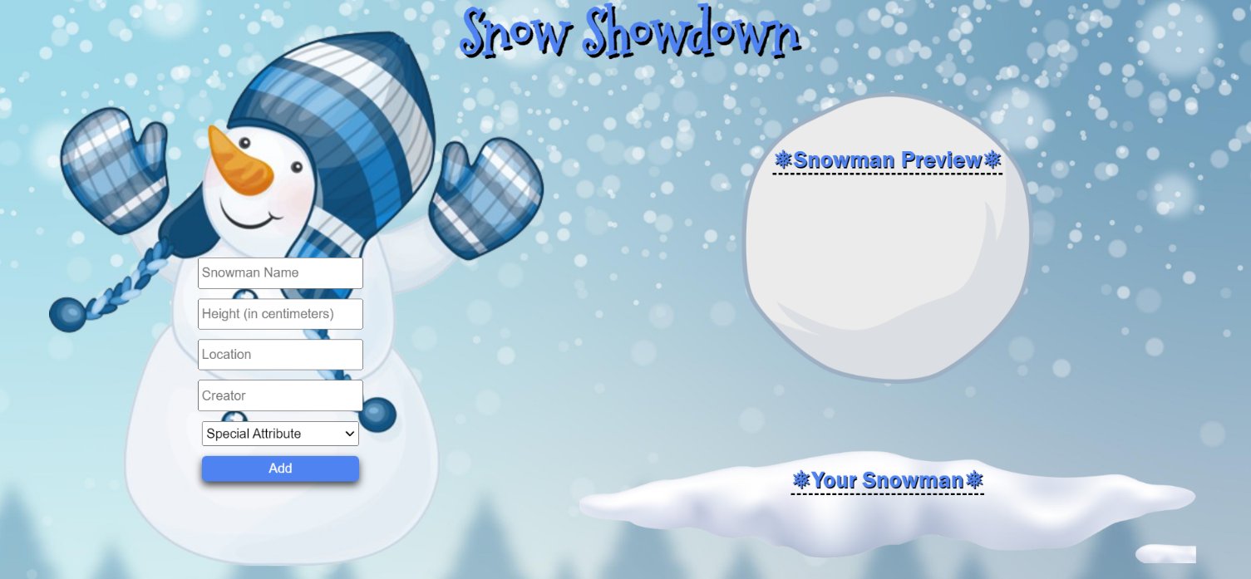

**Use the provided skeleton to solve this problem.**

**Write the missing functionality** of this user interface. The functionality is divided in the following steps:

**Write the missing JavaScript code** to make the **Snow Showdown** work as expected:

* All fields **(Snowman Name, Height (in centimeters), Location, Creator,** and **Special Attribute)** are **filled with the correct input**
* **Snowman Name, Height (in centimeters), Location, Creator,** and **Special Attribute** are **non**-**empty** **strings**. If any of them is empty, the program should not do anything.

### Getting the Information from the Form

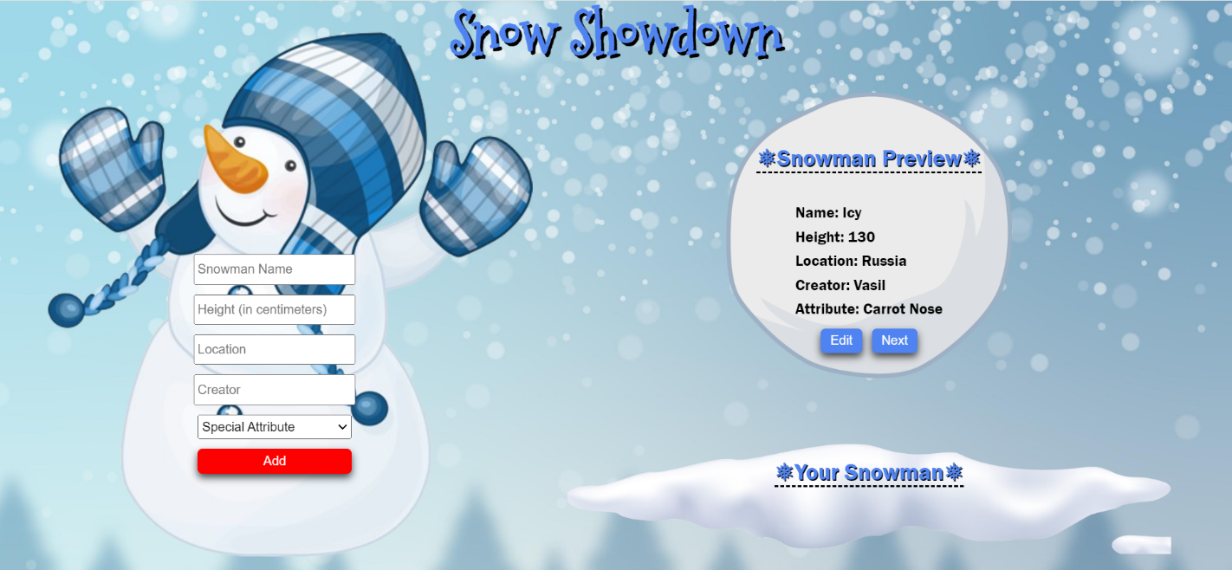

* When the **["Add"]** button is clicked, the information from the input fields is listed in the "**Snowman Preview**" section. A **list item** is added to the **"snowman-preview "** unordered list.
  + The list item should follow the same text format and order as shown in the provided picture.
  + When the button is clicked, the **input** fields must be **cleared**, and the **["Add"]** button should be **disabled**. Additionally, the **"Edit"** and **"Next"** buttons need to be added.

The HTML structure looks like this: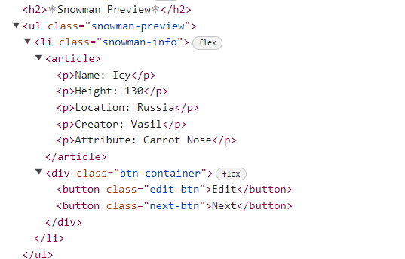

### Edit Snowman

**The functionality here is the following:**

* **When the "**Edit" **button is clicked, all of the information is loaded in to the input fields from step 1 and all the buttons in Snowman Preview section are removed while the** ["Add"] **button is enabled again.**

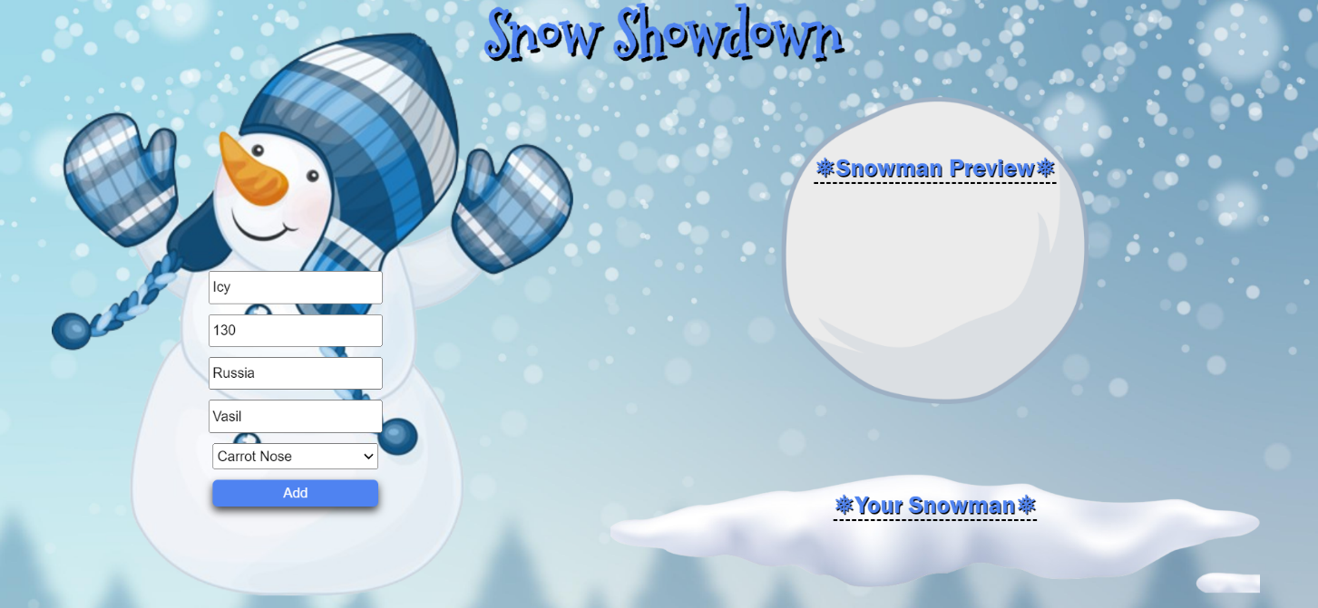

* **The list items must be removed from the** "snowman-preview"

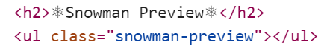

### Next

* **When the** "Next" **button is clicked,** **the information from** "snowman-preview" unordered list must be transferred to "snow-list". **For you, this means removing everything inside of the <ul> with class =** "snowman-preview" **and adding in** "snow-list", **the list item with same information** The "Send" button must be **added.**

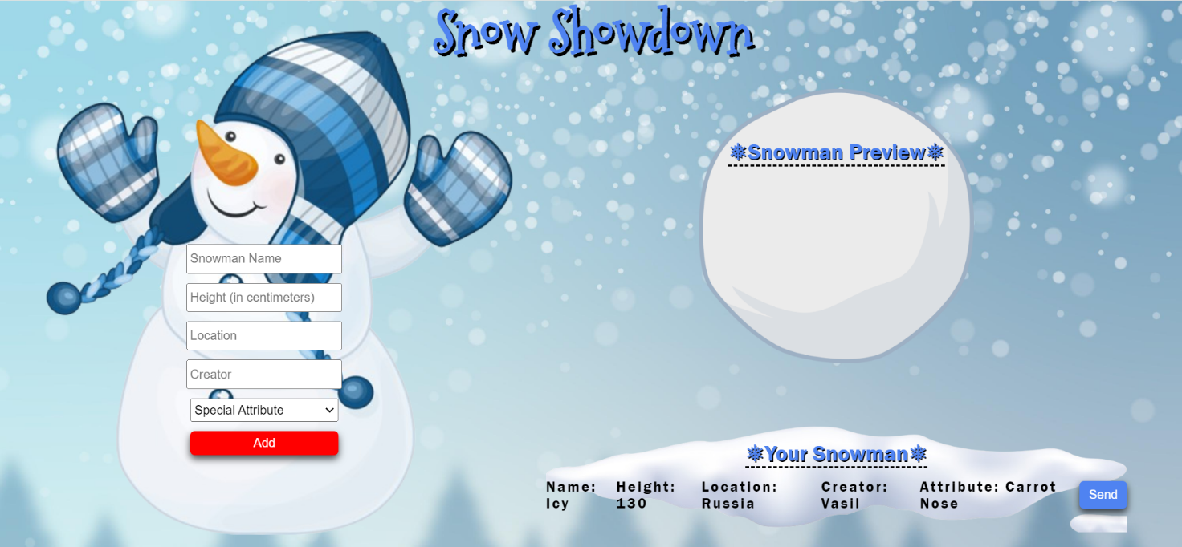

* **This is the HTML** structure **of the** "snow-list" unordered list**:**

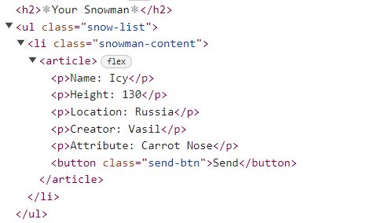

### Sending

* **When the** "Send" **button is clicked,** you must remove **main** element from the HTML structureand then **add** "Back" **button** to the **body** and make **visible** the image with **id "back-img"**

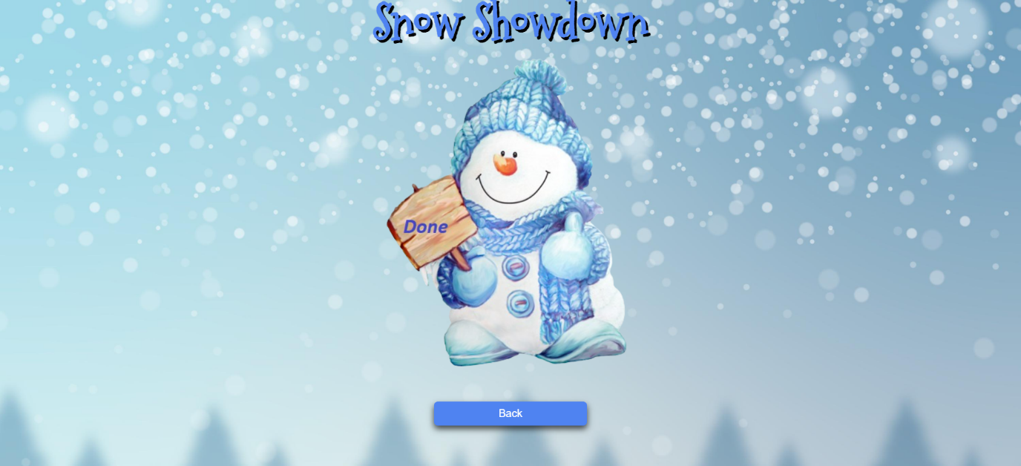

* **This is the HTML** structure **of the** body**:**

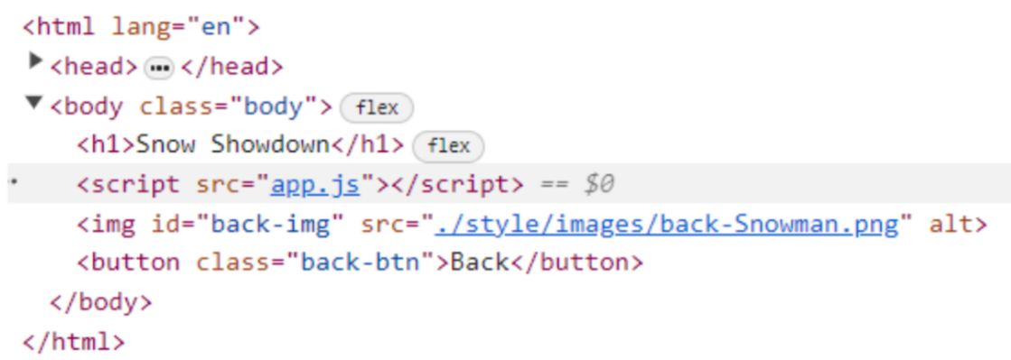

### Back

* **When the** "Back" **button is clicked,** you must **reload** the page.

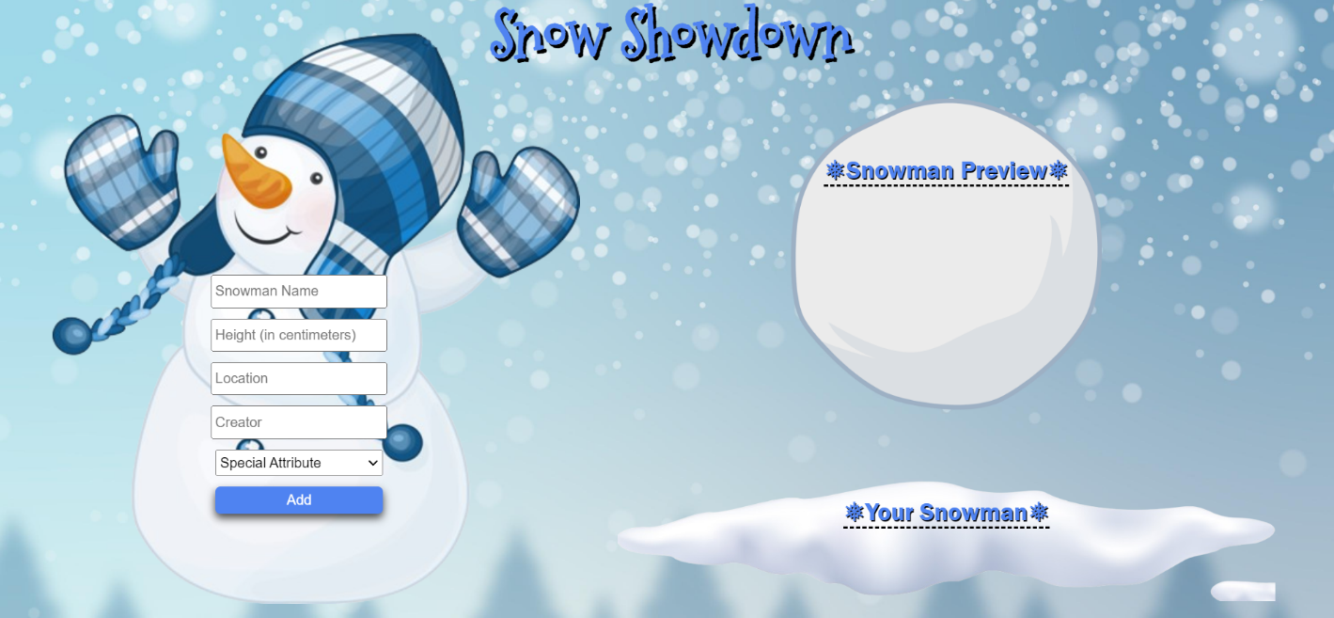

## JS Application Testing

You have been given a JavaScript application. All the necessary setup is complete, allowing you to start writing your tests. Your goal is to write integration tests using QUnit and end-to-end (Front-End) tests using Playwright.

### App Introduction

The **application for testing** is called **"Meme Lounge"**. It's a user-friendly application offering functionalities and permissions based on user login status:

1. For **guest user**:

* **Home Page**: View a brief introduction to the app.
* **All Memes page**: See all created memes.
* **Register/Login page**: Option to register a new account or log in.

1. For **Logged-In user**:

* **Create Meme Page**: Ability to create new memes.
* **All Memes**: See all created memes (both their own and others').
* **Profile Page**: View their profile and all memes they have created.
* **Logout**: Option to log out of the app.

1. **Meme details functionality**:

* **Detail View**: Both guests and logged-in users can see detailed information about a meme.
* **Edit/Delete Buttons**: Only the owner of a meme can see and use the Edit and Delete buttons in the detail view to modify or remove the meme.

1. **Navigation bar**: Provides easy access to application functionalities based on your login status (logged in or guest).

Also, there will be seeded data for 5 memes, that will always be loaded when you start the application.

### Instructions

A **folder named "tests"** is prepared for you. This folder contains **two subfolders**:

* **"QUnit_tests" folder** – for your integration tests with QUnit tests.
* **"Playwright_tests”** – for your Front-End tests with Playwright.

In **the "QUnit_tests" folder have 2 files**:

* **"integration.test.js"** – In this file, you have to write your QUnit tests.
* **"test.html"** – This is an HTML document that allows you to visualize your QUnit test results in a web browser.

**Note:** To **view the HTML document and test results from your QUnit tests in the browser**, you'll need the **"Live Server" extension** installed in VS Code.

In **the "Playwright_tests" folder**, you will find **a single file named "e2e.test.js"**. In it, you have to write your Front-End tests with the Playwright framework.

As for execution of the tests, **you need to start the back-end server of the application and the HTTP server**. Everything is configured for you, so you need just **to execute two commands in two Terminals**:

* **"npm run server"** – to start the application back-end server.
* **"npm start"** – to start the HTTP server.

**Note**: You will need to use **a third Terminal window for the execution of Playwright tests**.

### Integration Testing with QUnit

**Hint:** Before you start writing your integration test, you may need to **configure the test execution order**. Also, **use console.log() to check the JSON structure of the response**.

Write the following integration tests with QUnit for the "Meme Lounge" application:

#### Register Testing (User Functionality)

1. **Create Test Scope.**
2. **Send Register Request:** Use the fetch API to send a request to **"**<http://localhost:3030/users/register>**"** with**:**

* **Method POST**
* **Headers**:
  + 'content-type' : 'application/json'
* **Body:** Stringified user data - **JSON.stringify(user)**
* **User data Example:**

{

"username": "username_123456",

"email": "abv12546@abv.bg",

"password": "123456",

"gender": "male"

}

1. **Check Response:** Verify if the response is successful**.**
2. **Convert Response to JSON.**
3. **Verify JSON Properties:** Check each property of the JSON response.

**Hint:** You may need to use Math.random() for username and email.

#### Login Testing (User Functionality)

1. **Create Test Scope.**
2. **Send Login Request:** Use the fetch API to send a request to **"**<http://localhost:3030/users/login>**"** with**:**

* **Method POST**
* **Headers**:
  + 'content-type' : 'application/json'
* **Body:** Stringified user login data - **JSON.stringify({email, password})**

1. **Check Response:** Verify if the response is successful**.**
2. **Convert Response to JSON.**
3. **Verify JSON Properties:** Check each property of the JSON response.

**Hint:** You will **need user data such as access token and user Id for CRUD functionalities**.

#### Get All Memes Testing (Meme Functionality)

1. **Create Test Scope.**
2. **Send Login Request:** Use the fetch API to send a request to **"**<http://localhost:3030/data/meme?sortBy=_createdOn%20desc>**"** with**:**

* **Method GET**

1. **Check Response:** Verify if the response is successful**.**
2. **Convert Response to JSON.**
3. **Verify JSON as Array**.
4. **Loop Through Array**:

* Ensure each property exists.
* Verify the property type.

#### Create Meme Testing (Meme Functionality)

1. **Create Test Scope.**
2. **Send Register Request:** Use the fetch API to send a request to **"**[http://localhost:3030/data/meme](http://localhost:3030/users/register)**"** with**:**

* **Method POST**
* **Headers**:
  + 'content-type' : 'application/json'
  + 'X-Authorization' : token
* **Body:** Stringified meme data - **JSON.stringify(meme)**
* **Meme data Example:**

{

"title": "random_title_123456",

"description": "random_description_534554",

"imageUrl": "/images/2.png"

}

1. **Check Response:** Verify if the response is successful**.**
2. **Convert Response to JSON.**
3. **Verify JSON Properties:** Check each property of the JSON response.

#### Edit Meme Testing (Meme Functionality)

1. **Create Test Scope.**
2. **Send Register Request:** Use the fetch API to send a request to **"**<http://localhost:3030/data/meme/:memeId>**"** with**:**

* **Method PUT**
* **Headers**:
  + 'content-type' : 'application/json'
  + 'X-Authorization' : token
* **Body:** Stringified meme data - **JSON.stringify(meme)**

1. **Edit at least one property of the meme**.
2. **Check Response:** Verify if the response is successful**.**
3. **Convert Response to JSON.**
4. **Verify JSON Properties:** Check each property of the JSON response.

**Hint**: Replace ":memeId" with saved meme Id value from the previous test.

#### Delete Meme Testing (Meme Functionality)

1. **Create Test Scope.**
2. **Send Register Request:** Use the fetch API to send a request to **"**<http://localhost:3030/data/meme/:memeId>**"** with**:**

* **Method DELETE**
* **Headers**:
  + 'X-Authorization' : token

1. **Check Response:** Verify if the response is successful**.**

**Hint**: Replace ":memeId" with saved meme Id value.

### Front-End Testing with Playwright

You are provided with predefined configurations in the e2e.test.js file:

* Needed imports for Playwright:



* Predefined variables that you can use:

Картина, която съдържа текст, екранна снимка, Шрифт

Описанието е генерирано автоматично

* Before and after test configurations:

Картина, която съдържа текст, екранна снимка, Шрифт

Описанието е генерирано автоматично

* Test suits:

Картина, която съдържа текст, екранна снимка, Шрифт

Описанието е генерирано автоматично

Use them and write the following e2e tests with Playwright for the "Meme Lounge" application:

#### Registration with Valid Data (Authentication Functionality)

1. Create a test scope.
2. **Go to** [**http://localhost:3000**](http://localhost:3000)
3. **Locate and click on the Register button**.
4. **Wait for the register form to load**.
5. **Create a unique username and email value**.
6. **Locate and fill the input field for username.**
7. **Locate and fill the input field for email.**
8. **Locate and fill the input field for password**.
9. **Locate and fill the input field for repeat password**.
10. **Get the response by creating a Promise scope**. Wait for **the response to have a status of 200** and for the **URL to contain "/users/register"** and **press the submit button** for the form.
11. **Assert that the response is okey**.
12. **Parse the response to JSON**:
13. **Assert** that the **email and password** are as expected.

**Hint**: Use the predefined user object to hold and reuse user data.

#### Login with Valid Data (Authentication Functionality)

1. Create a test scope.
2. **Go to** [**http://localhost:3000**](http://localhost:3000)
3. **Locate and click on the Login button**.
4. **Wait for the register form to load**.
5. **Locate and fill the input field for email.**
6. **Locate and fill the input field for password**.
7. **Get the response by creating a Promise scope**. Wait for **the response to have a status of 200** and for the **URL to contain "/users/login"** and **press the submit button** for the form.
8. **Assert that the response is okey**.
9. **Parse the response to JSON**.
10. **Assert** that the **email and password** are as expected.

#### Logout from the Application (Authentication Functionality)

1. **Create a test scope**.
2. **Go to** [**http://localhost:3000**](http://localhost:3000)
3. **Log in to the application**.
4. **Get the response by creating a Promise scope**. Wait for **the response to have a status of 204** and for the **URL to contain "/users/logout"** and **click on Logout button**.
5. **Assert that the response is okey**.
6. **Wait for Login button.**
7. **Assert that the URL is for home page.**

#### Navigation for Logged-In User Testing

1. Create a test scope.
2. **Go to** [**http://localhost:3000**](http://localhost:3000)
3. **Log in to the application**.
4. **Assert that "All Memes", "Create Meme", "My Profile" and "Logout" buttons are visible**, and **"Login" and "Register" buttons are hidden.**

#### Navigation for Guest User Testing

1. Create a test scope.
2. **Go to** [**http://localhost:3000**](http://localhost:3000)
3. **Assert that "All Memes", "Create Meme", "My Profile" and "Logout" buttons are hidden**, and **"Login" and "Register" buttons are visible.**

#### Create a Meme Testing (CRUD Functionality)

1. Create a test scope.
2. **Go to** [**http://localhost:3000**](http://localhost:3000)
3. **Log in to the application**.
4. **Locate and click the "Create Meme" button**.
5. **Wait for the create meme form to load**.
6. **Locate and fill the input field for title**.
7. **Locate and fill the input field for description**.
8. **Locate and fill the input field for imageUrl**.
9. **Get the response by creating a Promise scope**. Wait for the **response to have a status of 200** and for the **URL to contain /data/memes"** and **press the submit button** for the form.
10. **Assert that the response is okey**.
11. **Parse the response to JSON**.
12. **Assert that title, description and imageUrl** are as expected.

#### Edit a Meme Testing (CRUD Functionality)

1. Create a test scope.
2. **Go to** [**http://localhost:3000**](http://localhost:3000)
3. **Log in to the application**.
4. **Locate and click on "My Profile" button**.
5. **Locate and click on first meme’s Detail button**.
6. **Locate and click on Edit button**.
7. **Wait for the Edit form to load**.
8. **Locate and fill at least one of edit form fields to change/edit a meme**.
9. **Get the response by creating a Promise scope**. Wait for the **response to** **have a status of 200** and for the **URL to contain /data/memes"** and **press the submit button** for the form.
10. **Assert that response is okey**.
11. **Parse the response to JSON**.
12. **Assert that title, description and imageUrl** are as expected (**with** **edited values**).

#### Delete a Meme Testing (CRUD Functionality)

1. Create a test scope.
2. **Go to** [**http://localhost:3000**](http://localhost:3000)
3. **Log in to the application**.
4. **Locate and click on "My Profile" button**.
5. **Locate and click on first meme’s Detail button**.
6. **Get the response by creating a Promise scope**. Wait for the **response to have a status of 200** and for the **URL to contain /data/memes"** and **press the delete button**.
7. **Assert that the response is okey**.

## How to Submit Your Work

You need to submit your work on the SoftUni website in the Exam Section.

1. Create a folder.
2. Put the folders of both applications in it – the DOM manipulation app and the JS Application Testing app:

Картина, която съдържа текст, Шрифт, екранна снимка

Описанието е генерирано автоматично

1. Go to the JS Application Testing app folder and delete the "node_modules" folder:

Картина, която съдържа текст, екранна снимка, Шрифт, номер

Описанието е генерирано автоматично

1. Archive the folder that contains both applications and your solutions.
2. Upload the archive to the SoftUni website in the course section for your exam.